*Stephen Collis*

1/7 Cheam Walk, Highton, 3216

**Ph:** 0423412029

**E-mail:** [scollis@deakin.edu.au](mailto:scollis@deakin.edu.au)

**Resume  
Professional Skills**

**Information Communication Technology Skills (Workplace only):**

* **System Administration & Level 1-3 support:** 
  + *Active Directory*; Account creation, Password changing, logon scripts and Drive mapping, Object placement within OU’s and general permission management.
  + *VMware and Hyper*-v; both server and client virtual machines.
  + *Group Policy*; Creation and maintenance, WMIC, multiple site/subnet policies.
  + *DHCP, WSUS,* and DNS server management.
  + Full management of Print server in 2003 and 2008 environment. Print management services and software; HP web jetadmin, Papercut, server print and document services.
  + *Pronto Enterprise Resource Planning; system administration. (Linux Redhat distribution)*
  + *Windows Registry*; remote registry management, unmounting and editing offline registry hives, in depth knowledge of structure and application.
  + *Much More…*
* **Hardware:** 
  + Full repairs on *Laptops*; Screens, Bezels, and all other internal components (RAM, HDD, NIC etc).
  + *Interactive White Board* (Firmware and device drivers), *Projector* maintenance and repair, general audiovisual set-up.
  + *Desktop and Thin Client*, extensive troubleshooting and auditing.
  + *Switch & Router* setup and configuration, in both “in-band” and “out-of-band” (mainly CISCO IOS), have had extensive education and some field experience.
  + *Printer and copiers*; Configuration and installation, stock maintenance and troubleshooting faults.
  + *VOIP* related phone systems, server, and voicemail call services.
* **Web Development & Programming skills (Workplace only):**
  + WordPress and Magento – front-end curation. And using, Html/css, javascript and PHP.
  + Company Intranet (html & css) – Creation and content management, IIS server, email automation. And automated helpdesk emails/templates.
  + PowerShell and remote batch scripting, mainly enforcing group policy related settings on non-domain computers. General system admin automation.
  + Database Management and Administrator: SQL executed via scripts or console
* **Image and Software Deployment:** 
  + *SCCM 2012;* Large-scale software & image deployment, extensive client side troubleshooting and identifying issues with task sequences or corrupt config manager clients, logs, and error codes.
  + *Windows Deployment Server (MDT & ADK);* setup & configuration of the server along with creating and deploying images (.WIM). Along with other local imaging tools (Clonezilla, Ghost).
  + *PDQ Deploy and Inventory;* package creation, scripts, deployment and use across multi-site WAN.
  + *FTP server;* duplication of data and deployment packages across WAN.

**Educational Skills Matrix**

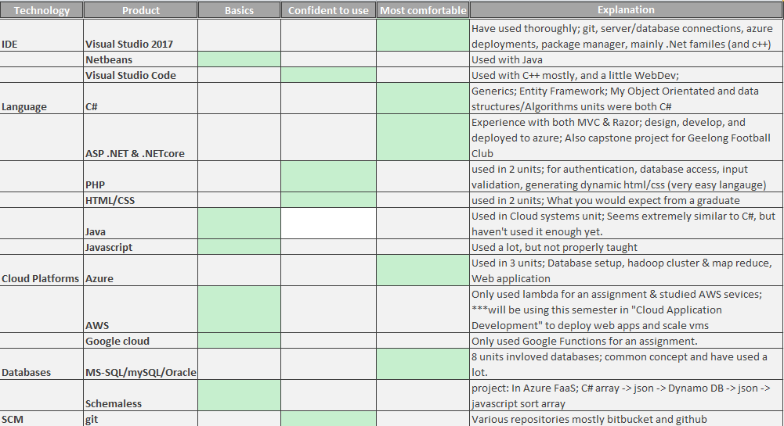

**Employment History**

**November 2015 - Current IT Business Support Office**Part time* with full time university Geelong Regional Library Corporation

|  |  |
| --- | --- |
| **May 2014 – December 2015**  Full time | **System Administrator**  Basford Brands |
| **January 2014 – May 2014**  Casual | **ICT Help Desk**  Basford Brands |
| **March 2012 – December 2013**  Full time | **ICT Technician/Trainee**  Geelong High School |
| **January 2012 & January 2013**  Casual | **I.T. Project staff**  gPowered and CBS @ Geelong High and Bellarine College |
| **August 2011** – **March 2012**  Casual | **Bartender/Bottleshop assistant/Waiter**  Peninsula Hotel, Geelong |
| **April** – **December 2010**  **February** – **March 2012**  Casual/Contract | **Library Assistant/project staff**  Deakin University, Waurn Ponds and Waterfront campus |
| **September – December 2009**  Casual | **Waiter**  Clyde Park Winery, Bannockburn |
| **March – August 2009**  Full time | **Kitchen Staff Supervisor**  Empire State Hotel, Inglewood |
| **November 2007- March 2009**  Full time | **Hotel Manager/ Bar/ Kitchen**  Empire State Hotel, Inglewood |
| **2005 - November 2007**  Casual | **Kitchen Hand**  Clarendon Hotel on Latrobe, Geelong |

**Education**

**Current University Results**

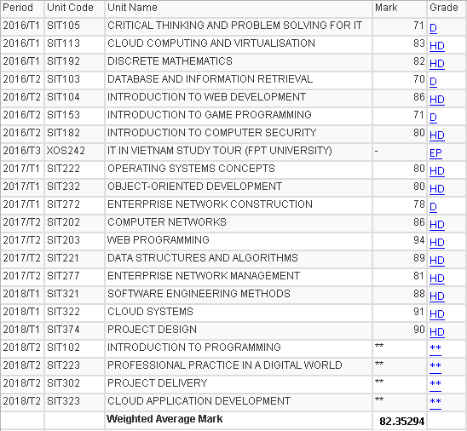

**2016 – Ongoing Bachelor Information Technology**

**(Units Completed 16/24) Majors: Cloud, Programming**

Deakin University

**2014 Cisco CCNA Certification (Expired)**

**2012 – 2013 Certificate IV in Information Technology: Networking**

Gordon Tafe, Geelong West

**July 2010 –Completed Dec 2010 CompTIA A+ CISCO IT Essentials**

Gordon Tafe, Geelong West, Through Netacad

**2002-2007 High School; VCE – SCCE**

St. Joseph’s College, Newtown

**Referees**

|  |  |
| --- | --- |
| **James Doof (Former Colleague)**  Software Engineer  AGL Australia  **Ph:** 0431043178  **Email:** [doof.j.l@gmail.com](mailto:doof.j.l@gmail.com) |  |

**Paul Wilkinson (Former Manager)**

Chief Operating Officer  
Basford Brands  
**Ph:** 0419726382 **Email:** [pwilkinson@basfordbrands.com](mailto:pwilkinson@basfordbrands.com)

**Brad Swaffield (Former Colleague)**ICT Technician  
Extreme Technology **Ph:** 0432677645

**Geoff Adsett (Current Manager)**Manager, ICT Operations  
**Phone:** 03 4201 0545  
**Mobile:** 0418 932 248  
**Email:**  [geoff.adsett@grlc.vic.gov.au](https://mail.grlc.vic.gov.au/owa/redir.aspx?C=WDIW0GClZUG1mRM_a0vivXQdtkBTdtQI1lYKgzodIrVMEeOVi2vywPtEkAwmXoW9hbLKgsa0IiM.&URL=mailto%3ageoff.adsett%40grlc.vic.gov.au)